**JS Applications - Cyberpunk Market**

**Environment Specifics**

Please be aware that every JS environment may **behave differently** when executing code. Certain things that work in the browser are not supported in **Node.js**, which is the environment used by **Judge**.

The following actions are **NOT** supported:

* **.forEach()** with **NodeList** (returned by **querySelector()** and **querySelectorAll()**)
* **.forEach()** with **HTMLCollection** (returned by **getElementsByClassName()** and **element.children**)
* Using the **spread-operator** (**...**) to convert a **NodeList** into an array
* **append()** in Judge (use only **appendChild()**)
* **prepend()**
* **replaceWith()**
* **replaceAll()**
* **closest()**
* **replaceChildren()**
* Always turn the collection into a **JS array** (forEach, forOf, et.)

If you want to perform these operations, you may use **Array.from()** to first convert the collection into an array.

You are expected to exclusively utilize JavaScript without relying on external frameworks like React, Vue, or Angular to tackle the given challenges.

You are assigned to implement a **Web application** (SPA) using JavaScript. The application should dynamically display content, based on user interaction and support user-profiles and CRUD operations, using a REST service.

1. **Overview**

**Implement** a front-end app (**SPA**) for creating and managing **Items records**. The application allows visitors to browse through the **Market** catalog. Users may **register** with an **email** and a **password** which allows them to **create** their own item records info. Item authors can also **edit** or **delete** their own publications at any time.

1. **Application Requirements**

**Navigation Bar (5 pts)**

Implement a **NavBar** for the app:

Navigation links should correctly change the current page (view). All users can see the site **logo** that should be a link to the **Home** page as well as the navigation link to **Market** page. **Guests** (un-authenticated visitors) can see the links to the **Login** and **Register**. The logged-in user navbar should contain the links to the **Sell**, page and a link for the **Logout** action.

**Logged-in User** navigation example:



**Guest** navigation example:



**Home Page (10 pts)**

Implement a static **Home page** for the app using the structure for it from the given resources. 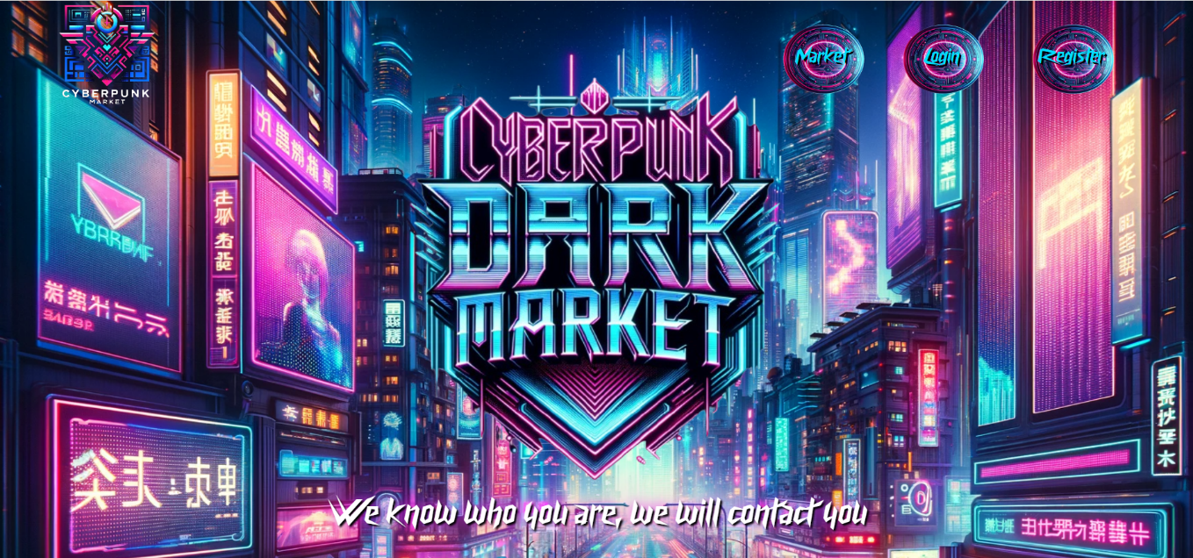

**Login Page (5 pts)**

The **included REST service** comes with the following **premade** user accounts, which you may use for development:

**{ "email": "peter@abv.bg", "password": "123456" }**

**{ "email": "john@abv.bg", "password": "123456" }**

The **Login** page contains a form for existing user authentication. By providing an **email and password** the app should log a user in the system **if** there are **no empty fields**.

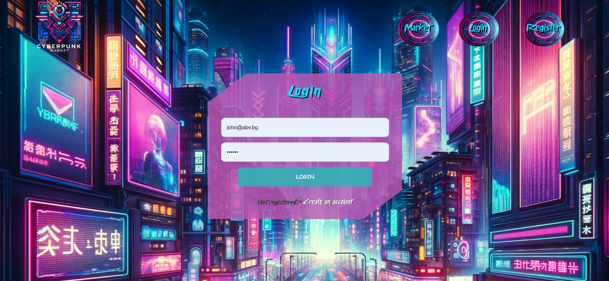

Send the following **request** to perform login:

**Method:** POST

**URL:** /users/login

The required **headers** are described in the documentation. The service expects a body with the following shape:

**{**

**email,**

**password**

**}**

Upon success, the **REST service** will return the newly created object with an automatically generated **_id** and a property **accessToken**, which contains the **session token** for the user **–** you need to store this information using **sessionStorage** or **localStorage,** in order to be able to perform authenticated requests.

If the login was successful, **redirect** the user to the **Home** page. If there is an error, or the **validations** don’t pass, display an appropriate error message, using a system dialog (**window.alert**).

**Register Page (10 pts)**

When the user enters an **email,** a **password** and a **password confirmation**, theapp should register a new user in the system. All fields are required – if any of them is empty, or the **password** and **repeat password** doesn't match, display an **error** with text "**Passwords don't match**".

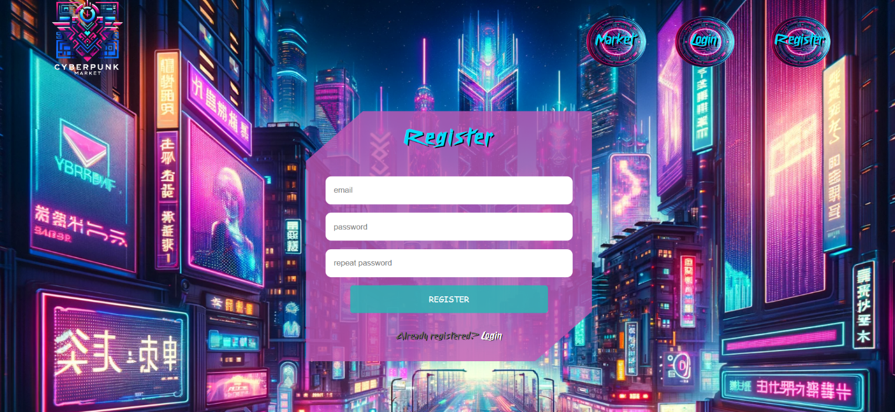

Send the following **request** to perform registration:

**Method:** POST

**URL:** /users/register

Required **headers** are described in the documentation. The service expects a body with the following shape:

**{**

**email,**

**password**

**}**

Upon success, the **REST service** will return the newly created object with an automatically generated **_id** and a property **accessToken**, which contains the **session token** for the user **–** you need to store this information using **sessionStorage** or **localStorage,** in order to be able to perform authenticated requests.

If the registration was successful, **redirect** the user to the **Home** page. If there is an error, or the **validations** don’t pass, display an appropriate error message, using a system dialog (**window.alert**).

**Logout (5 pts)**

The logout action is available to **logged-in users**. Send the following **request** to perform logout:

**Method:** GET

**URL:** /users/logout

The required **headers** are described in the documentation. Upon success, the **REST service** will return an **empty response**. Clear any session information you’ve stored in browser storage.

If the logout was successful, **redirect** the user to the **Home** page.

**Dashboard (15 pts)**

This page displays a list of all Items in the system. Clicking on the Uncover More button in the item leads to the details page for the selected item. This page should be visible to guests and logged-in users.

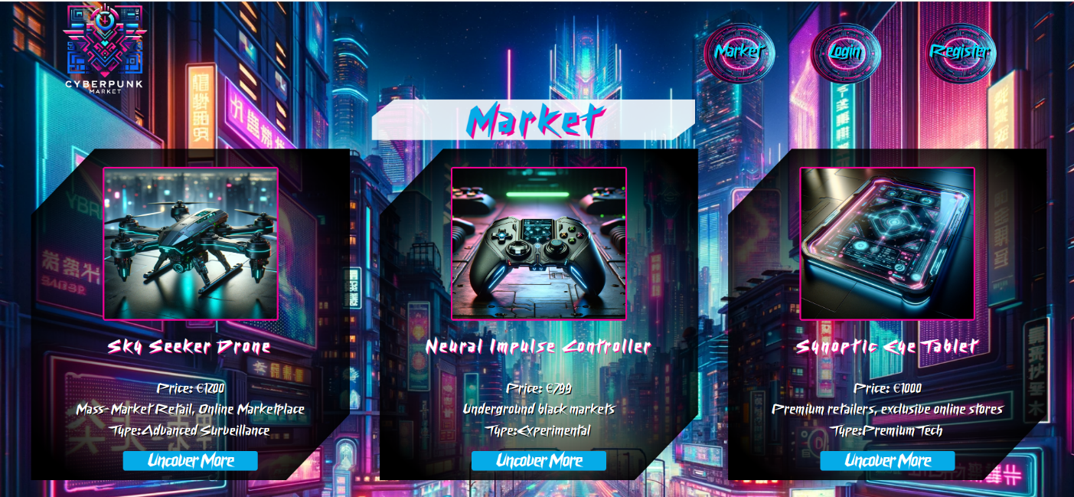

If there are **no Items**, the following view should be displayed:

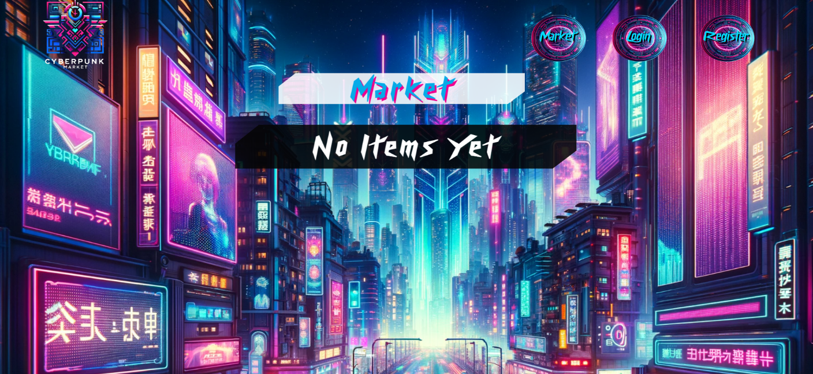

Send the following **request** to read the list of records:

**Method:** GET

**URL:** /data/cyberpunk?sortBy=_createdOn%20desc

The required **headers** are described in the documentation. The service will return an array of Items.

**Adding a New Item(15 pts)**

The Create page is available to **logged-in users**. It contains a form for adding a new item. Check if all the fields are filled before you send the request.

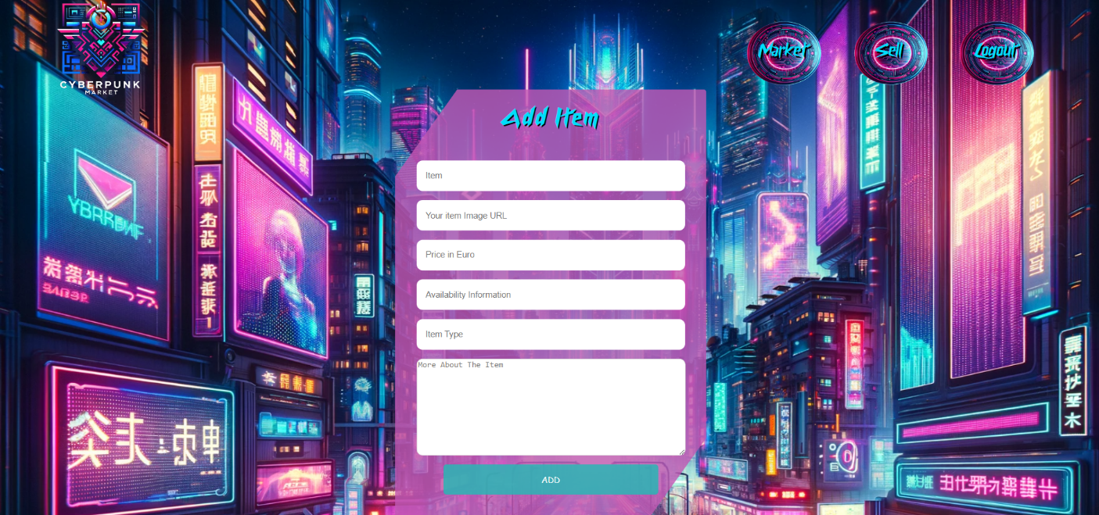

To create item record, send the following **request**:

**Method:** POST

**URL:** /data/cyberpunk

The required **headers** are described in the documentation. The service expects a body with the following shape:

**{**

**item,**

**imageUrl,**

**price,**

**availability,**

**type,**

**description**

**}**

The required **headers** are described in the documentation. The service will return the newly created record. Upon success, **redirect** the user to the **Market** page.

**Item Details (10 pts)**

All users should be able to **view details** aboutitem. Clicking the **Uncover More** button in a **item** should **display** the **Details** page. If the currently **logged-in user** is the **creator**, the **Edit** and **Delete** buttonsshould be displayed. Otherwise, they should not be available. The view should look like this to the **creator** of the item record:

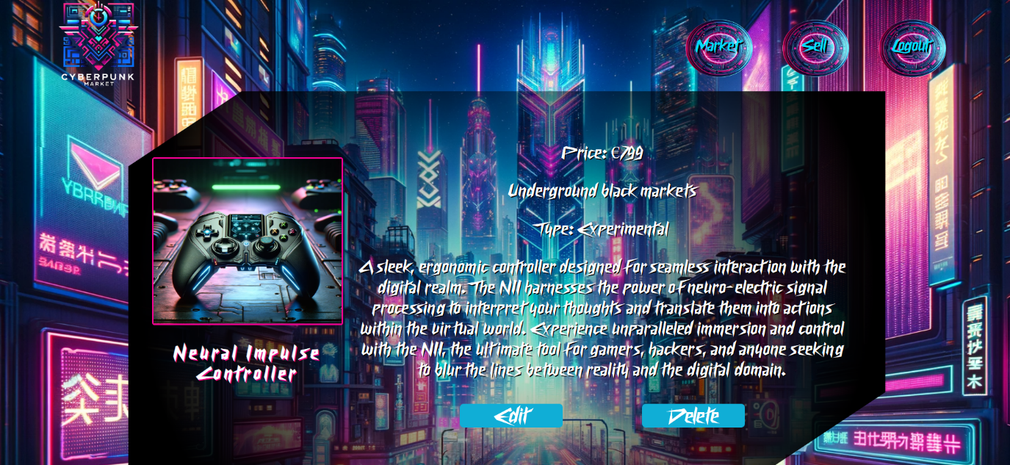

The view for **guests** and **registered** users who have not created the item record should look like:

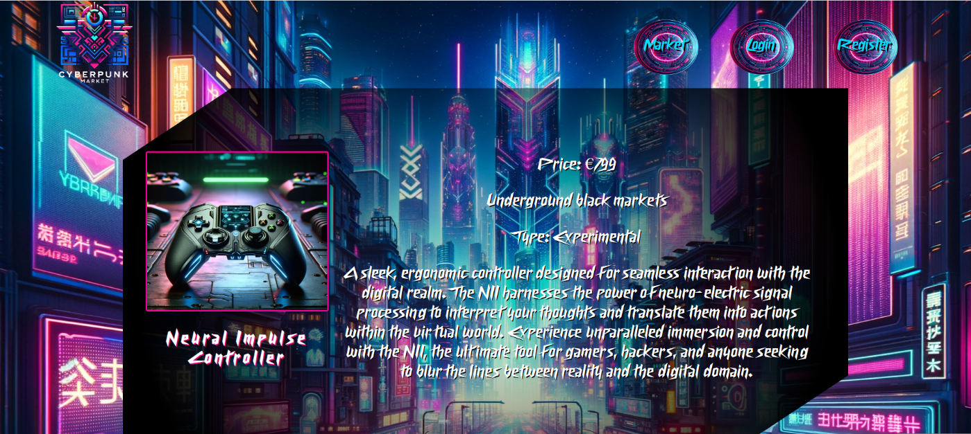

Send the following **request** to read a single item:

**Method:** GET

**URL:** /data/cyberpunk/***:id***

Where ***:id*** is the **ID** of the desired itemd. The required **headers** are described in the documentation. The service will return a single object.

**Editing a Item Record (15 pts)**

The Edit page is available to logged-in users and it allows authors to **edit** their **own** item records. Clicking the **Edit** link of a particular item on the **Details** page should display the **Edit** page, with all fields filled with the data for the item. It contains a form with input fields for all relevant properties. Check if all the fields are filled before you send the request.

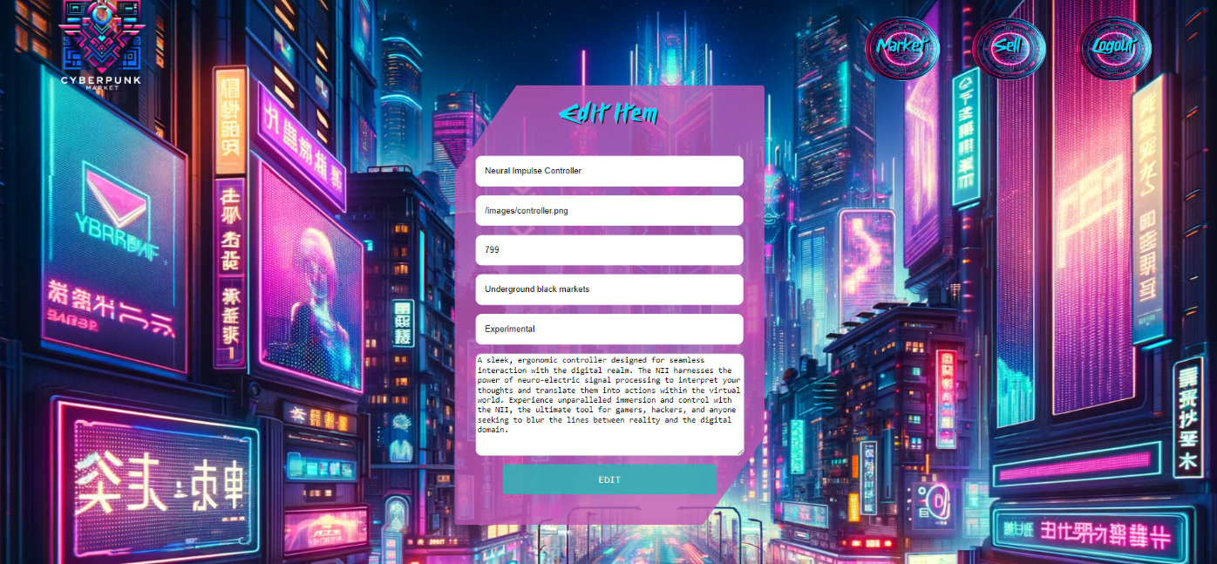

To edit a item record, send the following **request**:

**Method:** PUT

**URL:** /data/cyberpunk/***:id***

Where ***:id*** is the **id** of the desired itemd.

The service expects a **body** with the following shape:

**{**

**item,**

**imageUrl,**

**price,**

**availability,**

**type,**

**description**

**}**

Required **headers** are described in the documentation. The service will return the modified record. Note that **PUT** requests **do not** merge properties and will instead **replace** the entire record. Upon success, **redirect** the user to the **Details** page for the current item.

**Delete a Item Record (10 pts)**

The delete action is available to **logged-in users**, for item records they have created. When the author clicks on the Delete action on any of their item, **a confirmation dialog should be displayed**, and upon confirming this dialog, the record should be **deleted** from the system.

To delete item record, send the following **request**:

**Method:** DELETE

**URL:** /data/cyberpunk/***:id***

where ***:id*** is the **id** of the desired item. Required **headers** are described in the documentation. The service will return an object, containing the deletion time. Upon success, **redirect** the user to the **Market** page.

### BONUS: Notifications (15 pts)

In case of **error caused by the user’s actions**, the application should display an **error notification message instead of an alert**, which disappears after 3 seconds. There is a **styled section** with **id "notifications"** and **styled div** with **id="errorBox" that has** CSS property **display** initially set to **none** in the provided HTML file.

Errors may include **validation errors** or error **messages returned** by the REST service, such as incorrect user credentials, on the following pages: **Register**, **Login**, **Create** and **Edit**.

Some of the tests are made to catch both window.alert and error notification message, you should **only use one** way to **display errors**!

